Iris Rokvic

World Building Final Project – ENGL3086

December 13, 2024

Table of Contents
Good Girl, Original Short Story……………………………………………………………...pp3-8
Good Girl, World Building Exercise / Rewrite……………………………………………..pp9-14
Reflection………………………………………………………………………………….pp15 -18

Good Girl, original short story

Anna lit another cigarette and reclined her seat back. She sat in her car with the heat blasting and her window open. She had told her therapist, who had told her mother, which she thinks is illegal, but now she was in a parking lot waiting. Her cigarette filled her car with a smell that was familiar and that she knew her mother would hate. She was sweating and cold and tasted her bile each time she swallowed. She waited and waited and waited even though they said they would meet over an hour ago. She lit another cigarette and then quickly put it out as soon as she saw a car turning in down the street. Mother pulled into a spot across from Anna’s, and they looked at each other for a while.

Anna was a good girl. Her parents would always say that to everyone who asked about Anna. She was wholly unremarkable, but they could never admit that. She always did well in school as a child. She loved to read and write and make up choreography with her cousins that she would then force her family to watch in the living room as they performed. She was pretty, in the stereotypical way. Anna had long blonde hair that she would never cut short and green eyes that sometimes looked blue depending on the weather. She wore skirts more than jeans and always tied her hair with a pink or white bow, even as she grew older. Mother never really bothered to get to know her.
Anna was a good girl. She tried her best to win her father’s favor by learning about tennis and winning every math decathlon she would enter. She learned to cook his favorite foods and would play his favorite songs while she was cooking to see if he would notice. She would iron his clothes and make him coffee in the morning. He would throw it away on his way to work and buy himself Starbucks. Anna didn’t know that, though. Maybe Father didn’t like Anna because she looked so much like Mother. Maybe it was because she was trying too hard. Mother pretended like it wasn’t obvious.
Anna was a good girl. Her cousin would always tell her that she was good and that he was sorry and that he didn’t know why he did that. Anna didn’t know either. She did know that it made her feel like she needed to take a shower and that she shouldn’t ever be alone with anyone. Anna didn’t speak very often. She would lie and say that she had a bellyache anytime someone invited her to a sleepover. Her elbow would hurt when it was time to go camping. She had a headache when a boy invited her to the movies. Sometimes, even Anna’s hair would be so sore from being in a ponytail that she just couldn’t make it to the party. Mother bragged that Anna liked to spend her time studying.
Anna was a good girl. She learned quickly not to lie or exaggerate or speak when it wasn’t her turn. Things were easier that way. Mother taught Anna to look at her fingernails when things were uncomfortable. Look at each fingernail and take a deep breath and count each finger until you get to ten. There was no need to make a big deal. Mother and Father loved each other and just because they yelled didn’t mean anything bad. Yelling meant that they cared because if they didn’t care, they wouldn’t say anything at all. If they didn’t care, they wouldn’t have stayed together after everything. Mother reassured her that if they didn’t care, they wouldn’t hug after they had cleaned up the broken dishes off the kitchen floor.
Anna was a good girl. She spent the summer reading all the required books for the next semester, so she had more time to focus on her extracurriculars. She went to the pool a lot and sat under the umbrella and ate the kind of grilled cheese that had mac and cheese and bacon in between the slices of bread. She would swim laps during the adult swim and go back to her books after the thirty minutes were up. She listened to classical music in her headphones and tried not to get any of the pages wet, so she wouldn’t get a library fine. Mother would be disappointed with a library fine.
Anna was a good girl. When a boy noticed her walking home from the pool, he stopped and asked if she needed a ride. Anna said that she was okay and that it was a short walk. He said that Anna looked pretty. She said thank you to be polite. He insisted that Anna get in the car because it was going to rain, and she shouldn’t walk in the rain. So, she got in the car. He took her to McDonald’s, and he paid for her chicken nuggets and drove her around and talked and Anna listened. Then he parked in the church parking lot by the school and said that it was time for Anna to pay him back for her meal. He was much bigger than her and he played hockey, and she knew that he knew how to hit her. So, Anna paid for her meal, and he dropped her off at the end of her street and she said thank you. Mother didn’t concern herself with asking who dropped her off.
Anna was a good girl. When school started that fall, she went back to her normal routine and tried to keep up with her AP classes. She went to cross country practice in the mornings and swim club in the afternoons. She still cooked dinners and did laundry and sat with her family to tell them about her grades and what was going on at school. She was captain and she made varsity and although her parents didn’t care about high school sports, they were happy that it was something she could put on her resume. She won the state science fair, and her parents were proud, and they didn’t even fight on the two-hour drive home. She got all As and only cried in the bathroom for ten minutes when she was made vice president of her class. Mother was pleased.
Anna was a good girl. She applied to many different colleges but ended up going to the one close to home because she got the most scholarship money there. She joined a sorority and Spanish club and went to the library with her friends. She was doing well in all her classes, and her professors liked her. She joined the school’s honor society and local philanthropy organization. She went home once a week to have dinner with her parents and update them on her academic achievements. Mother would still check her grades with Anna’s school login once a week.
Anna was a good girl. She met a boy that she liked, and they went to dinners and the movies and on picnics. He bought her flowers and always walked her to her car and never yelled like her father. He wrote silly poems for her and read them aloud while he played his guitar. He went to formal with her and wore a matching tie. He learned to make pasta from scratch with her and drank the coffee that she made him. He sat with her at football games and was interested in her friends and wanted her to be friends with his friends, too. He hugged her and cuddled her, and it didn’t always have to lead to something else. He listened to her favorite songs and learned the words so he could sing along with her. He told her he loved her and held her hand as they walked to their lectures to show everyone that they were together. He even carried her books. Mother said that he was good.

Anna was a good girl. She tried to remind herself of that as he pushed her head into the pillow so hard that she couldn’t breathe. Anna was a good girl, and she prayed and prayed and prayed that one of the blows would cause her to lose consciousness so she wouldn’t have to think about what was happening to her. Anna was a good girl, and she couldn’t bring herself to open her mouth to say anything. Anna was a good girl, and she couldn’t say no. Anna was a good girl, and she was quiet. Anna was a good girl, and she didn’t fight back. Anna was a good girl, and she didn’t cry or scream. Anna was a good girl, and she lay there after he got up and went to the other room. Anna was a good girl, and she went to the bathroom and cleaned the blood off her face and her legs and put her clothes back on. Anna was a good girl, so she made the bed.
Anna was a good girl.
Anna was a good girl.
Anna was a good girl.
Anna was a good girl.

Anna jostled in her seat as Mother yanked on the car door handle. The car was locked. Anna fumbled around for her keys and finally, it beeped, and Mother opened the door and sat down in the passenger seat.
“Is it true?’
“Yes,” Anna said.
“Why didn’t you tell me?”
“Would it have made a difference?” Anna said.
Mother looked down at her fingernails. Her gaze followed her hand as it reached for the car door handle once more, and Mother walked back to her car.

Good Girl, World Building Exercise / Rewrite

She never really understood why her mother spent so much time in the kitchen. Her mother did not like to cook, the chairs by the island looked like you should not sit on them, and the island itself was too close to the wall to sit comfortably if you weren’t twig thin. The kitchen probably would’ve benefitted from another set of wall cabinets and more counter space instead of that little island only Mother could use. But there she was, sitting at the kitchen island with all of this month’s bills laid out favorably across the granite slab in front of her. As Anna peered through the window, she could see that Mother’s hair was mostly pushed back, with a few stringy pieces framing her eyes and blowing up in front of her as she huffed each breath. Her brows furrowed at the papers, probably because she gave up looking for the same glasses she always forgot were atop her head. Her posture was poised and erect, almost robotlike. The sweater she wore looked brand new, as if she had been waiting to wear it for this occasion. Anna noticed that her mother’s fingernails were freshly painted red and as long and tidy as they always were. I just could not give up having beautiful fingernails to play the piano, her mother would say; it’s just not ladylike to have them short. And it wasn’t.
Mother was the perfect lady on the outside: her pristine kitchen, the dusted baseboards, the shiny floors. The beds in the house looked like they were put together by hotel staff, always tucked precisely with fluffed pillows. The bathrooms smelled like daisies, and you could probably drink the toilet water if you wanted to without getting sick. The living room somehow always looked like a staging area at a real estate open house, even when they were kids running around making a mess. The messes made immediately vanished, like magic, and things were back to how they should be. The clothes in the closets were organized by color, season, and occasion. All of Mother’s dresses were flawlessly pressed and hung, waiting to be worn by her petite and classically desirable body. The entire house gleamed with a bright glow that Anna had never seen replicated anywhere else. It was as if her mother was waiting for a surprise inspection by her neighbor, or boss, or in-laws to prove that she was the best. This was what Anna always dreaded when she came back home.
Anna entered her mother's house the way everyone enters her house: through the garage door, which leads straight to the kitchen. I guess everyone knows that if you come through the front door, no one will be there to greet you, and you will inevitably find Mother at the kitchen island. She was like a Barbie you put down in one spot and found waiting there when you returned from school. Anna closed the door behind her, and her mother made a face that looked like she had just sniffed ammonia salts.

“What are you doing here!?” said Mother.

“I thought it would be better to get ahead of everything now that everyone knows.”

“Everyone knows what?”

Anna looked closely at her mother’s eyes. She couldn’t decide if she was lying. Her mother was the best liar she had ever met, with the ability to mimic facial expressions in order to show whatever emotion was needed to win. Mother always won whatever she started. She could cry, quiet her tone and speak softly, yell and seem taller than she really is… she could do it all. It was something Anna noticed when she was younger. It was Mother’s way of surviving Anna’s father. But once you start lying, even if it’s to protect yourself, you can’t stop.

“You haven’t heard? I thought maybe one of the moms would have told you.”

“Can you just get to the point, Anna? I have to mail all of these and cook dinner before your father gets home. If you wanted my undivided attention, then maybe you should have called me before barging in like this.”

“Now I’m barging in my own home, and last week it was ‘you never come see me anymore.’”

“Can we skip the smartass comments today?”

“Fine,” said Anna reluctantly.

Anna thought back to everything that happened. How could she tell her mother? How could she explain that this had been going on since she could remember? She held back tears and the bile that was coming up her throat. She wished she would have smoked before she came to her mother’s house, but she was worried she would know. She felt bad for her mother like she was going to let her down by telling her. She felt guilty as if she had somehow done this to her mother. She knew her mother would feel shame. She knew her father would yell at Mother for this. She knew her family would no longer be perfect, no matter how hard Mother tried.

“You know Cameron? Zoe’s older brother/”

“Yes. They’re a lovely family. What about him?”

Anna gulped. She could feel the sweat forming on her upper lip and her hands going numb.

“Cameron… well… I don’t…”

“Anna, you’re stressing me out. I have bills I need to get –”

“Cameron raped me, Mom.” Her mother said nothing. Her gaze stared past Anna.

“He did it over the summer, and it’s not the first time I’ve been abused, and I didn’t know how to tell you or what to do, and now people are finding out because I tried to talk to the counselor about it, and someone overheard at school, and I don’t know what to do Mom and –”

“Are you sure?”

The words hit Anna like a slap across her cheek. Was she sure? That’s the first thing her mother says to her? Anna knew that the conversation wouldn’t go well, but she didn’t think she would have to prove herself.

“Mom!”

“I’m asking you a question.”
“You don’t believe me?”

“It’s a simple question, Anna.”

The walls started closing in on her. The island grew to be giant and became this thing propelling her towards Mother. The cabinets pushed against Anna’s back, and the walls squeezed her tight. The baseboards wrapped around her ankles like rope, and the four chairs came on every side of her, caging her in. Anna breathed heavily and closed her eyes shut. She tried counting. She tried taking a deep breath. She opened her eyes, and the island grew even bigger. She couldn’t control it. Her mother’s voice echoed in her ears. Are you sure? Are you sure? Are you sure? Her mother’s perfect red fingernails started coming towards her. Her hand curled as it gripped around Anna’s neck. Anna couldn’t breathe.

“Anna!” shouted Mother. “Snap out of it!”

Anna quickly came to and realized there was no point. Her mother would never let go of what she knew, what she had to know, in order to survive.

“No. You’re right. I’m not sure. I apologize for bothering you and next time I will call before I come over.”

Anna walked back out through the garage and drove home.

Reflection

In my first short story, the world-building fell short primarily due to a lack of detail and specificity in the setting. The outer story setting was just in Anna’s car, and we did not really get any description other than that the heat was blasting, and it smelled like cigarettes. The backstory is more about the characters and their actions rather than any of the world around them, which is a different experience for the readers. The first story is more about how all the actions impacted Anna emotionally, but it lacks depth. I realized I hadn't invested enough time crafting a world that would immerse readers in the story. Additionally, I failed to integrate Anna’s world effectively into the narrative, leaving key elements unexplored and underdeveloped. Some of these elements, like her relationship with her mother, could have been fleshed out more through how they interacted in specific environments, like her mother’s house. I wanted to explore this in the excerpt I wrote for this project.

The second story or excerpt I wrote was set at Anna’s mother’s house instead of the car. The reader is introduced to the setting as Anna peers into the house through a window. I based the mother’s house and kitchen on my own mother’s house and went from there. Many details were changed to fit the character of Mother more than the real-life person of my own mother, and I looked to see how I could tailor specific details to inform the reader of what the character of Mother is like. Below is a mind map of how I came to some of the details of Mother’s house.

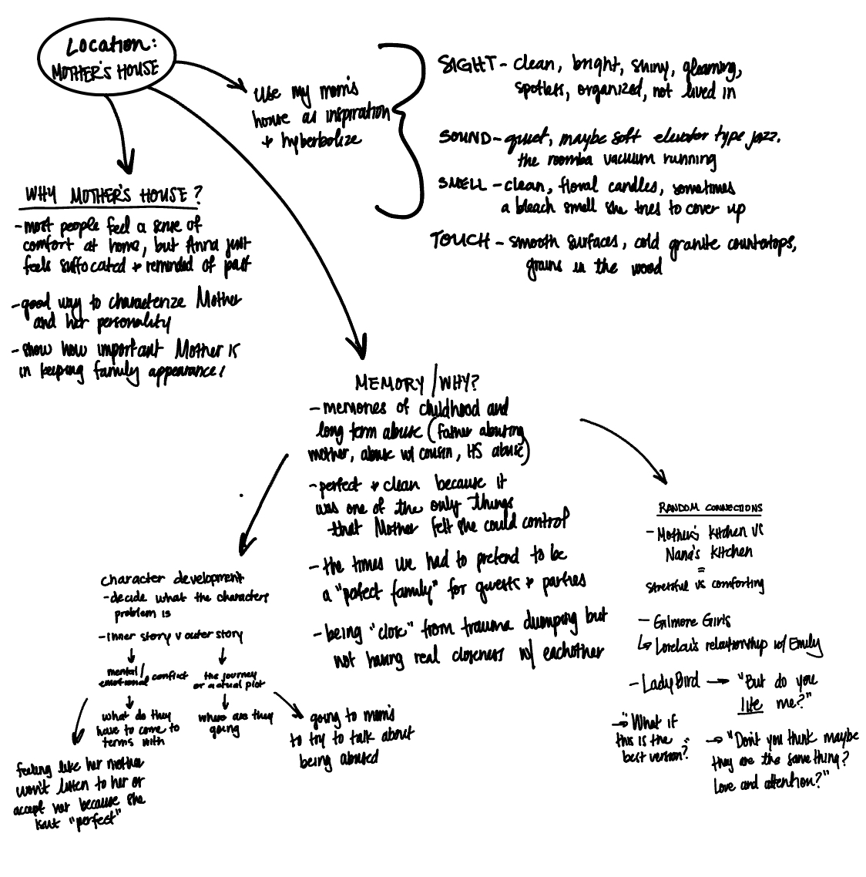

Using these ideas, I decided that all the details of the house would reflect all of Anna’s mother’s characteristics. The house would need to be super clean and feel like no one even lives there to exemplify that Mother had no warmth or personality outside of wanting to look perfect. Keeping the house clean or her appearances desirable is something that she could control, in a world where deep down she felt powerless. Even when they were children, the house felt like something constantly getting cleaned and fixed so there was never any mess. I also added that even though Mother spends most of her time in the kitchen, she doesn’t ever cook. This further shows the reader that Mother does everything for appearances rather than for her family or even herself. Later in the draft, I mentioned that Mother is a liar. This also ties back into her constant need for control, which we can see in the house but also in her actions. Lying can help her control the narrative of herself and her family.

Since this is only part of a much bigger story that I want to continue working on, I tried to keep their interaction brief but powerful. It is clear that Anna is nervous and unsure of how this will play out, but she is shocked when Mother says, “Are you sure?” This is a critical moment because it shows us that Mother is trying to either manipulate Anna to question her own reality or she is trying to get Anna to let it go and lie to change the narrative in her favor as Mother does. This sends Anna spiraling and causes her to imagine that the house that suffocates her emotionally begins to strangle her physically. The details of the house that she was observing prior come back to haunt her in her short breakdown.

All these things come together to show us both characters’ desires and how the characters and the world (of Mother’s House) are intertwined. This interaction would create further causality, push the story forward, and determine Anna’s next steps to find a solution and what she wants. I think this exercise was really beneficial for me, and I plan to continue trying to change the setting where their confrontation takes place and how each change affects how they act.

